1. Click on Tools and Settings

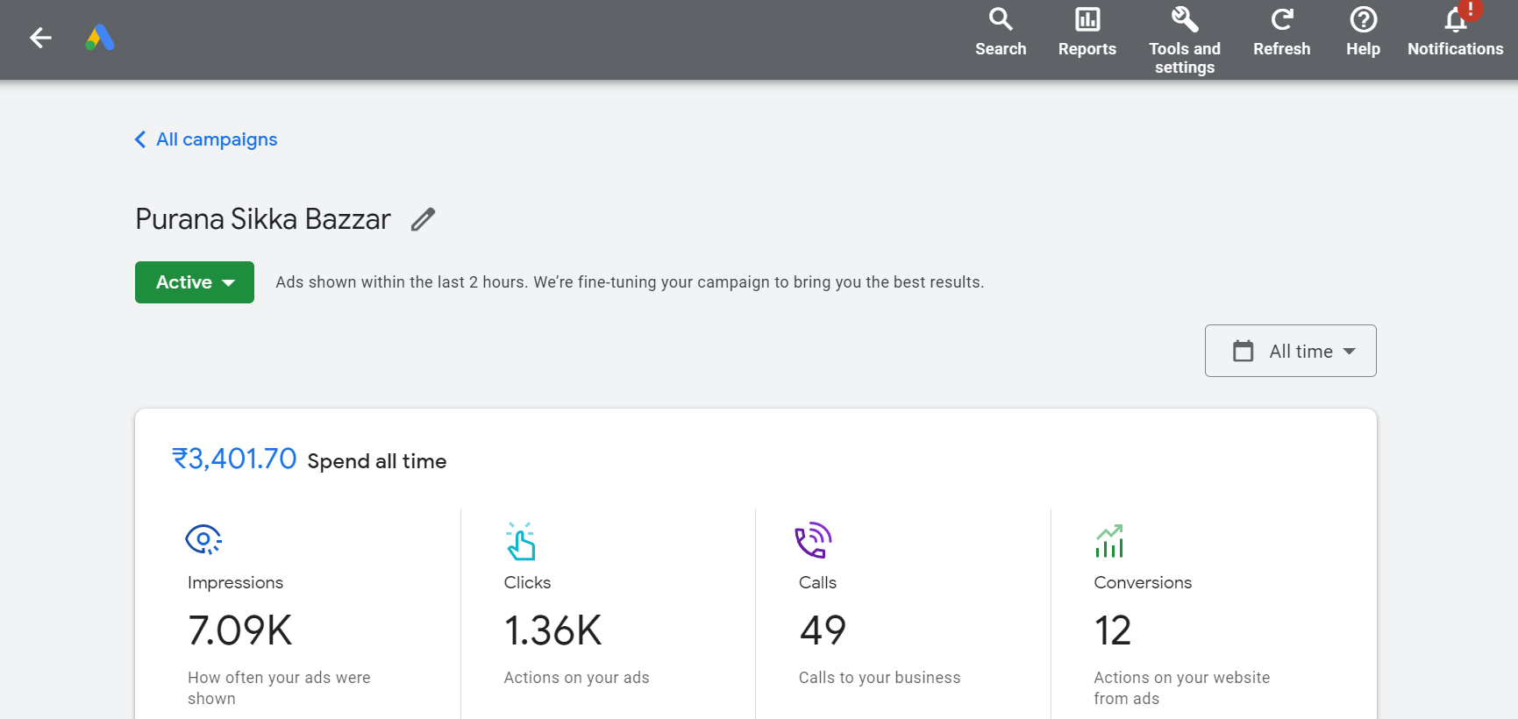

1. Click on Billing

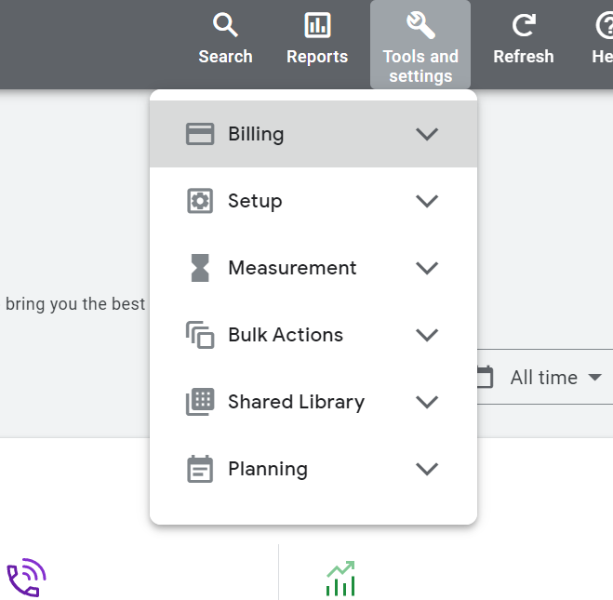

1. Click on Summary

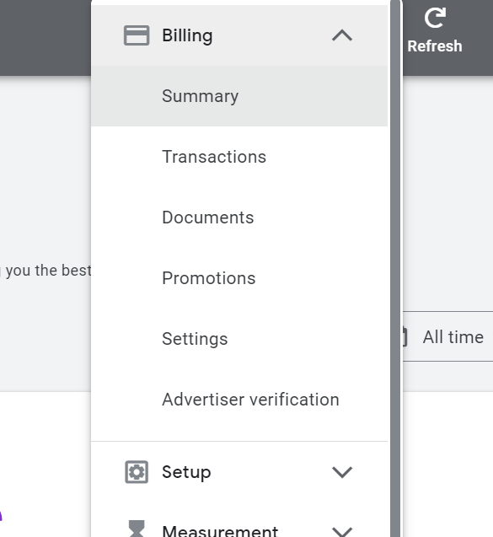

1. Click on Add Funds

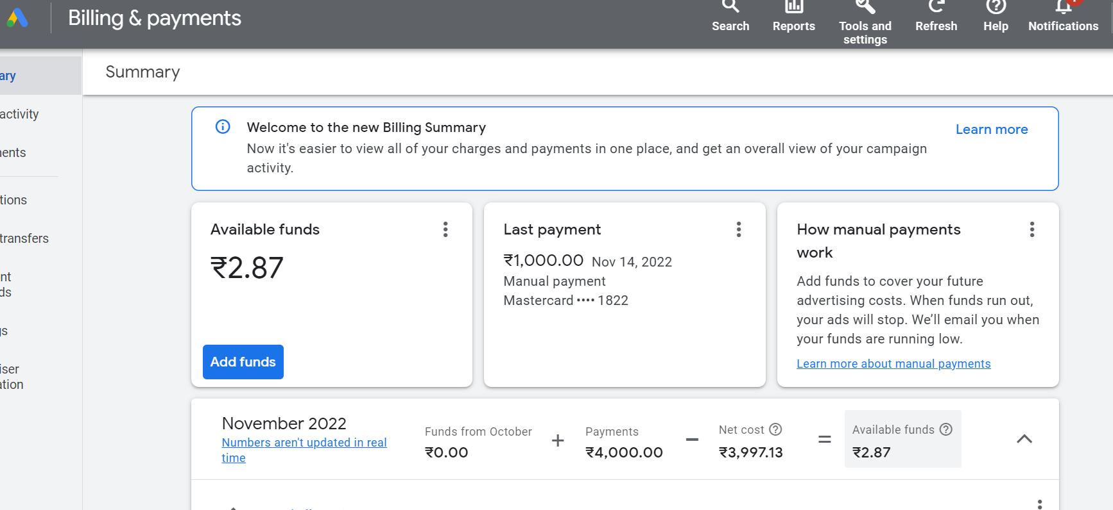

1. Select Credit Card, Enter Amount and press on Make payment

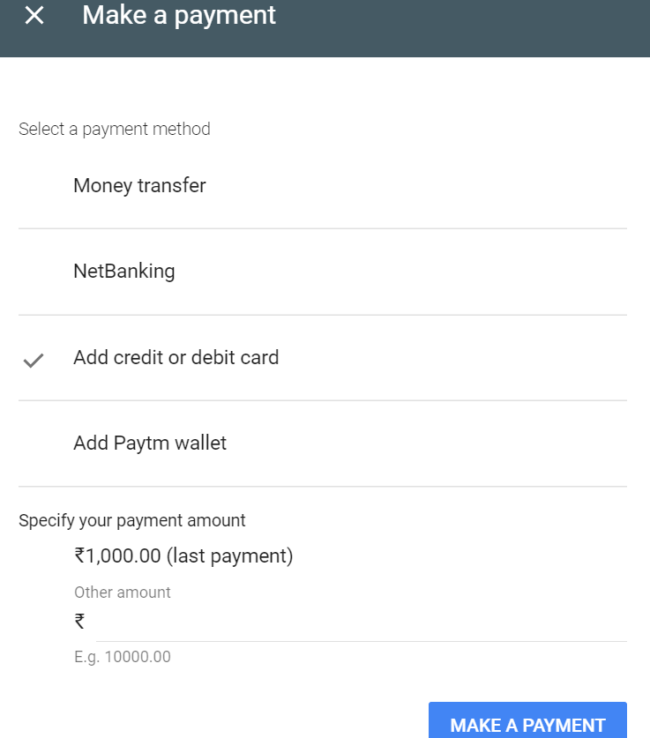

1. Enter OTP and Submit